**LECTURE 1**

* ***Definition***

Combinational devices: their outputs depend only on the current input combination (i.e., the combination of their input values)

* ***Definition***

Sequential devices: their outputs depend on the current input combination and the sequence of past inputs.

**LECTURE 2**

* ***Axioms of Switching Algebra***

|  |  |
| --- | --- |
|  |  |

* ***Theorems of Switching Algebra***

|  |  |  |
| --- | --- | --- |
|  |  |  |
|  |  |  |

|  |  |
| --- | --- |
|  |  |
|  |  |
|  |  |
|  |  |

* ***Duality***
* ***Minterms & Maxterms***

**LECTURE 3**

* ***Sum-of-Products -> Product-of-Sums***
* ***AND-OR -> NAND-NAND***
* ***OR-AND -> NOR-NOR***

**LECTURE 4-5**

* ***Karnaugh Maps***

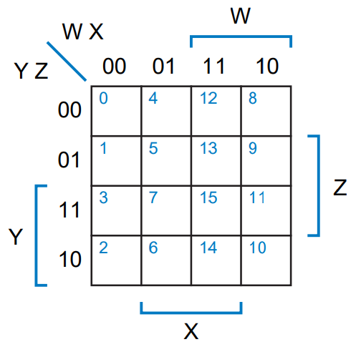

* ***Minimizing Sum-of-Product***
* ***“Don’t Care” Inputs (d)***
* *distinguished 1-cells*
* *prime implicant (essential & non-essential)*
* *complete sum & minimal sum*

**LECTURE 6-7**

* ***Multiplexer – 2n-to-1 (n inputs)***

|  |  |
| --- | --- |
|  |  |

* ***Decoder – n-to-2n***

|  |  |
| --- | --- |
|  |  |

* ***Encoder – 2n-to-n***

|  |  |
| --- | --- |
|  |  |

* + ***Expanding MUXs & Decoders***
  + ***Implementing Functions w/ Combinational Circuits***
* ***Read-Only Memory (ROM) – n inputs -> 2n options, m outputs***

|  |  |
| --- | --- |
|  |  |
|  |  |

* ***Programmable Logic Arrays (PLA)***

|  |  |
| --- | --- |
|  |  |
|  |  |

* ***Tri-State Buffer***

|  |  |
| --- | --- |
|  |  |

**LECTURE 8-9**

* ***S-R Latch (Set-Reset Latch)***

|  |  |  |
| --- | --- | --- |
|  |  |  |
|  |  |  |

* ***D Latch***

|  |  |  |
| --- | --- | --- |
|  |  |  |

* ***Edge-Triggered D flip-flop***

|  |  |  |
| --- | --- | --- |
|  |  |  |
|  |  |  |
|  |  |  |

* ***S-R flip-flop***

|  |  |  |
| --- | --- | --- |
|  |  |  |

* ***J-K flip-flop***

|  |  |  |
| --- | --- | --- |
|  |  |  |

* ***T flip-flop***

|  |  |
| --- | --- |
|  |  |
|  |  |

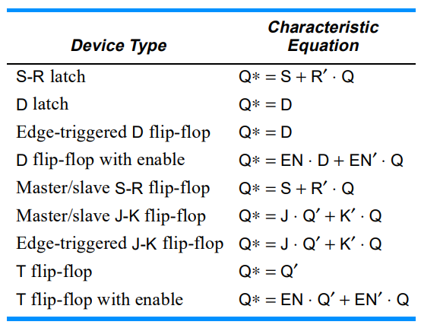

**LECTURE 10**

* ***1s Counting Machine***

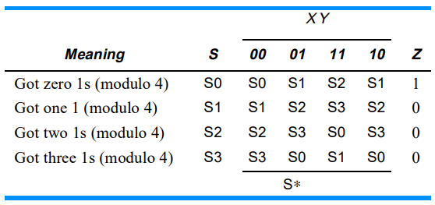

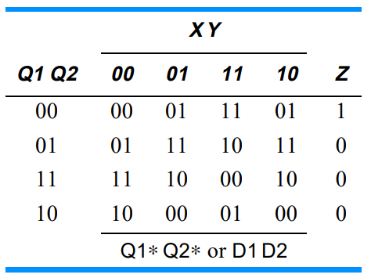

**LECTURE 11-12**

**LECTURE 13**